**Three leg pot**

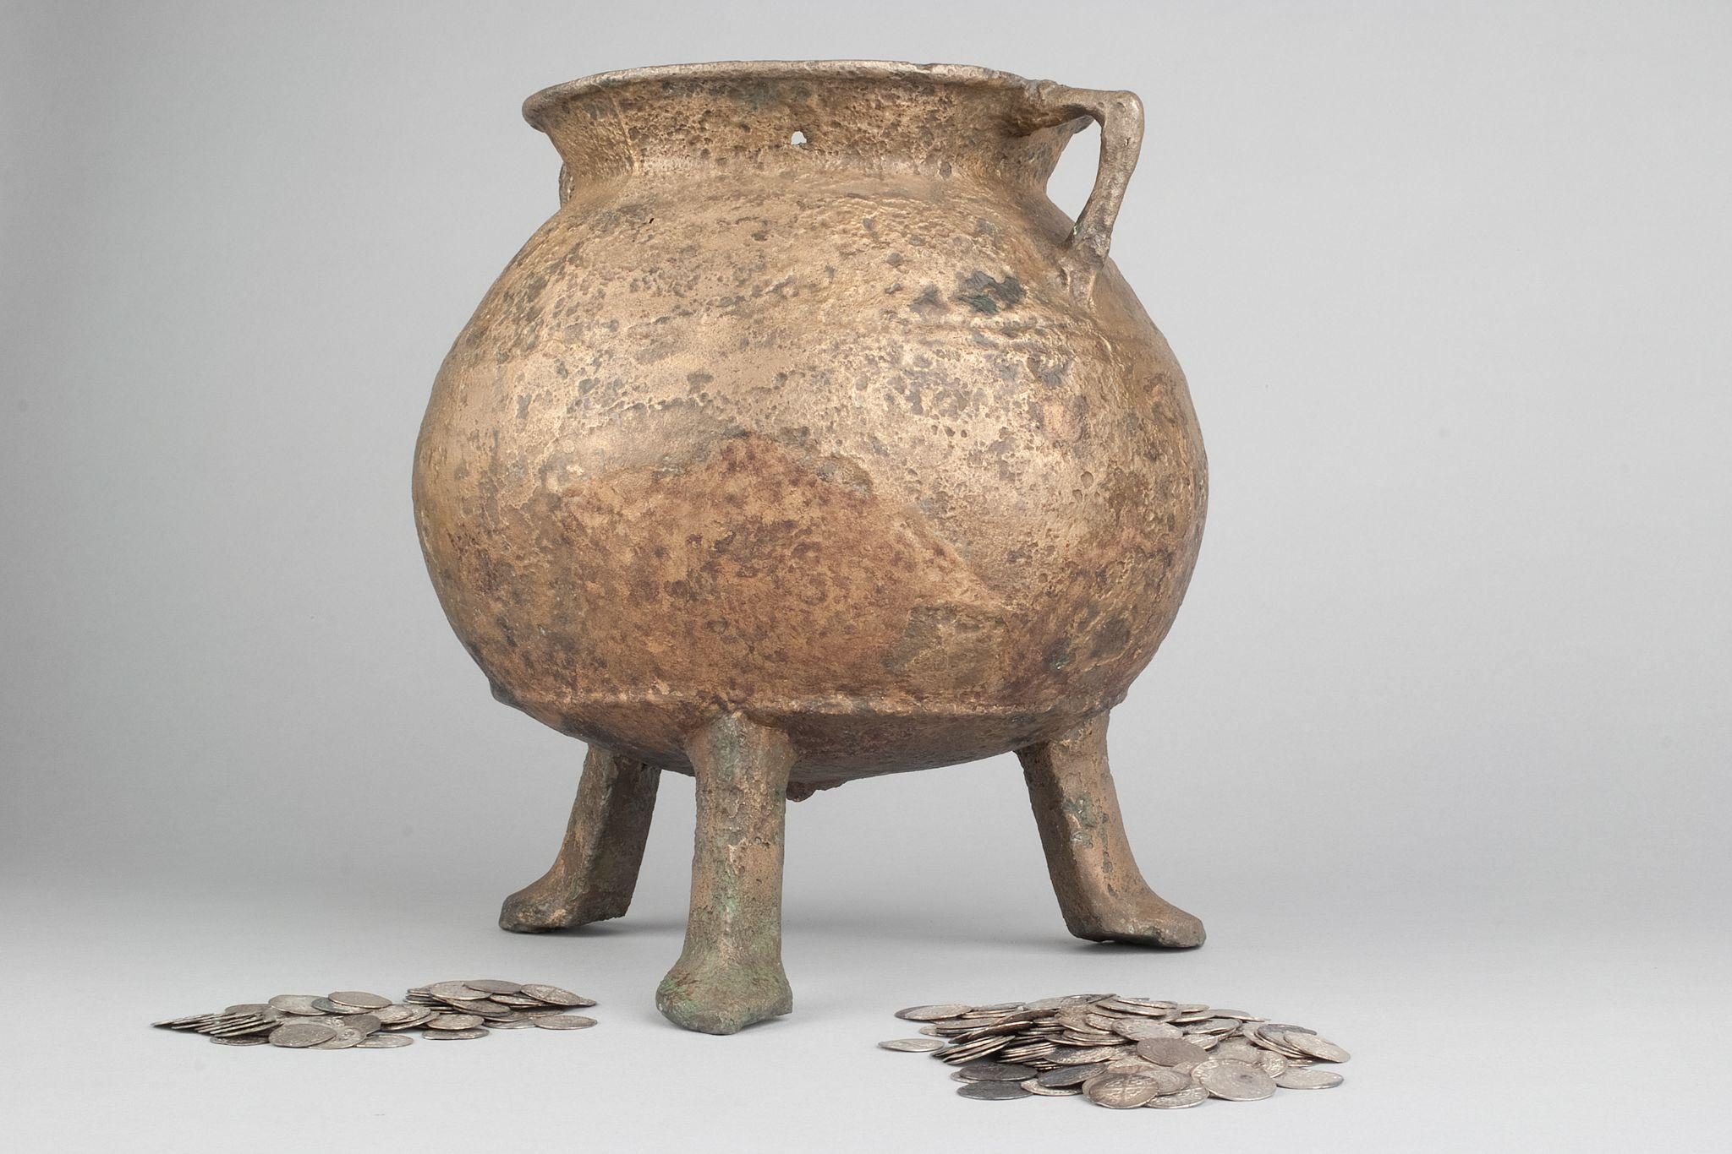

ABDMS023543.1

Some key links for background

* <https://emuseum.aberdeencity.gov.uk/objects/81342/upperkirkgate-coin-hoard-pot?ctx=b0ed040cfe3cd6588bdffae73c7b2625bd5491c2&idx=44#>
* <https://canmore.org.uk/site/20189/aberdeen-upperkirkgate>
* <https://online.aberdeenshire.gov.uk/smrpub/master/detail.aspx?tab=main&refno=NJ90NW0068>

**What am I?**

I’m a copper alloy cauldron. I’m not that large - only 27.8cm high by 24.4cm wide. I’m from the middle ages, I was buried in the ground for a long time.

**Who made me? Who owned me?**

Nobody remembers, but I would have been made by a hammerman (blacksmith). I might even have been made in Aberdeen!

**Where & when was I found?**

I was found in 1886 by workmen digging in the pavement in front of printshop in Upperkirkgate. The shop was Messrs King & Co.

Links: <https://digital.nls.uk/directories/browse/archive/86975456> (p. 190 / p. 185)



**What was found with me?**

Some 12,267 silver coins were found with me. They date from the 1200s (the reign of Alexander III) up to the reign of Robert I (1306-1329). But most of the coins found with me were English coins. Why so many English coins? There’s been lots of speculation based on this, such as the idea that this hoard was to pay English troops in Scotland. They were very common in medieval Scotland.

**Who buried me?**

Good question! I might have been buried by a wealthy merchant in Aberdeen, in fear of an attack on the city. The 1330s were a time of war - we had two kings, David Bruce and Edward Balliol. There was civil war and Balliol was supported by an English army, which attacked and burned Aberdeen in 1333.

**When was I buried?**

The youngest coin in the hoard was a penny of King Edward III of England, was minted no later than 1335. This means the earliest possible date when the hoard could have been concealed was 1335. More probably, I was buried with the hoard in the 1340s, still a time of war!